**CENTER FOR INTEGRATED HEALTH PROGRAMS**





**GAP** IDENTIFICATION **SYSTEM ANALYSIS PLUS**

**Version 1.0.0.0**

**Table of Content**

Table of content………………………………………………………………………………………………….1

Abbreviations……………………………………………….………………………..……………………………2

Acknowledgement…………………………………………………………..………………………………….3

Overview…………………………………..……………………………………….………………………………..4

GISAT PLUS App requirement……………………………….…………………………………..……….5

User guide Key Update…………………………………….……………..………………….…………..6-7

Lunching the app.…………………………………………………….………………………………..……….8

Generate line list……………………………………………………………………...…………….………9-10

Backup DB…………………………………………………………………………..…………………………….10

Importing line list…………………………………………….………………..…………………..…………..11

Merging line list………………………………..………………………………………..………………..12-13

**Abbreviations**

ART Antiretroviral therapy

CTT Client tracking and termination

DB Database

EMR Electronic medical record

EDEC Electronic data entry clerk

EXE Executable file

GISAT Gap identification system analytical tool

NDR National Data Repository

IP Implementing partner

LGA Local government area

NMRS Nigeria medical record system

Sql Structured query language

**Acknowledgements**

**Overview**

GISAT Plus is a cross platform application (Windows and iOS) focused on optimizing the identified internal data quality issues, unauthorized access to the backend and execution of unauthorized/unapproved SQL script. GISAT Plus - a Graphic User Interface (GUI) application to help address emerging issues with regards to data mining, data cleaning and Merging of line list from various facilities and state.

GISAT Plus Functionalities

1.    Reduction of access to the backend at the facility level

2.    Control mechanism and accurate use of CIHP approved updated scripts/stored procedure

3.    Perfect merging of line list with zero data error

4.    Enhancement of data consistency and accuracy.

5.    Monitor execution of unapproved script on the NMRS database

6.    Control and monitoring versioning of the scripts been developed.

7.    Accurate database backup

8.    Ease of line list generation using the dropdown functionality of the app

9.    Identification of errors for cleaning.

GISAT Plus app will enable the end user to call the following patient line list;

* Generate treatment line list
* Generate HTS line list
* Generate full Pharmacy component line list
* Generate PMTCT line list
* Generate EID line list
* Generate AHD line list
* Generate Daily LIMS-EMR line list
* Generate COVID-19 line list
* Generate Last 5 Pharmacy line list
* Generate OTZ line list

Other component of the application involves the following features

* Backup NMRS DB
* Truncate Line list DB
* Import line list
* Merge line list
* Identification of data entry related gaps

**GISAT PLUS App requirement**

1. Screen resolution recommendation is **1920x1080** and scaling is **100%** so as to have access to the full GISAT Plus app.
2. MySQL Server 5.7 (or higher) installation
3. Add MySQL\bin path to both the user variable and system variable (if needed) to allow the app have access to the MySQL dump functionality.
4. Database name should be “openmrs”
5. MySQL Server Credentials (Known to the administrator)
6. User must be an admin machine (Computer) user. i.e Login access should be Administrator rights
7. "GISAT_Plus**.sql"** file**.**

**USER GUIDE – Key Updates**

**ENVIRONMENT VARIABLE SET-UP**

**STEP 1:** Search for **environment variable** in the window bar and double click

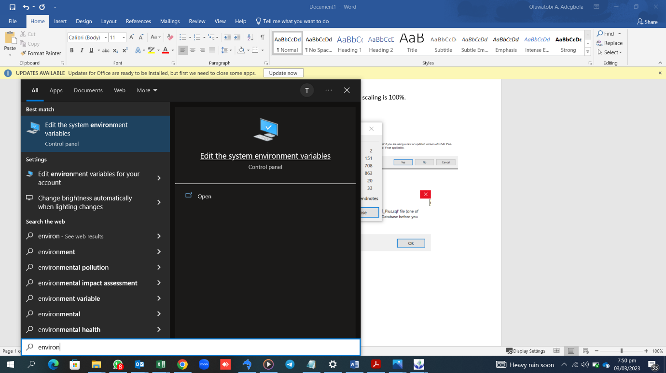

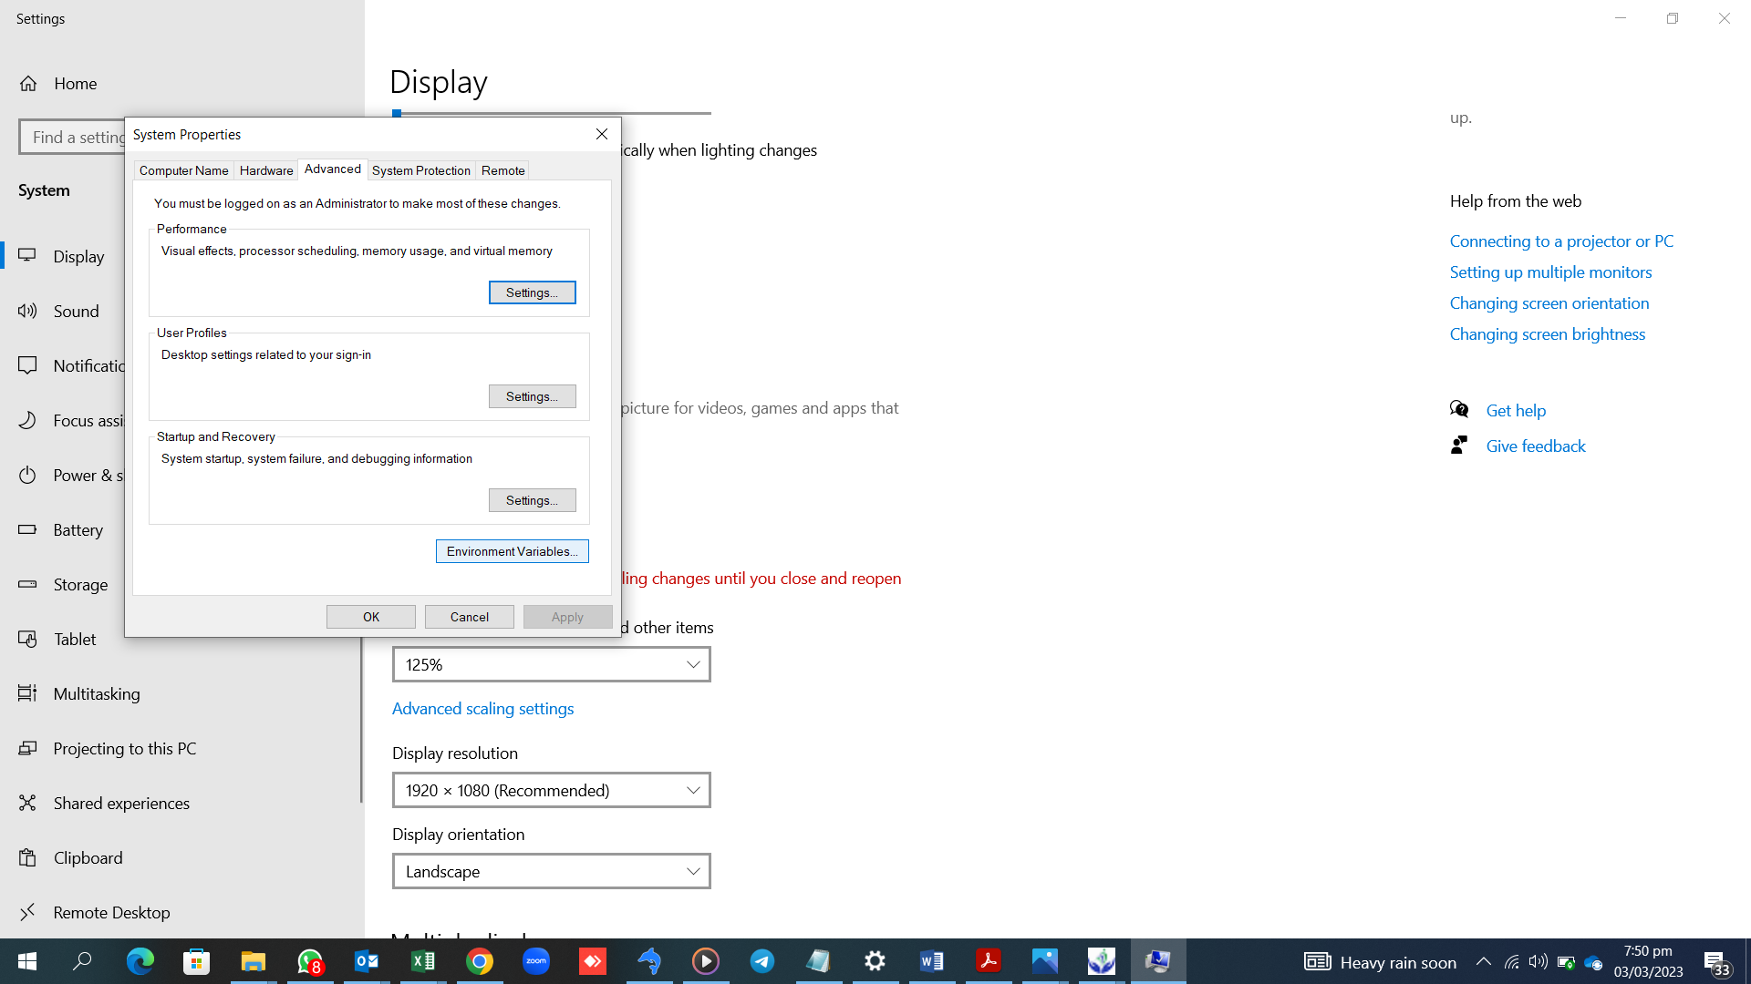**STEP 2:** Select **environment variable**

**STEP 3:** On the User variables, select path and Click on edit

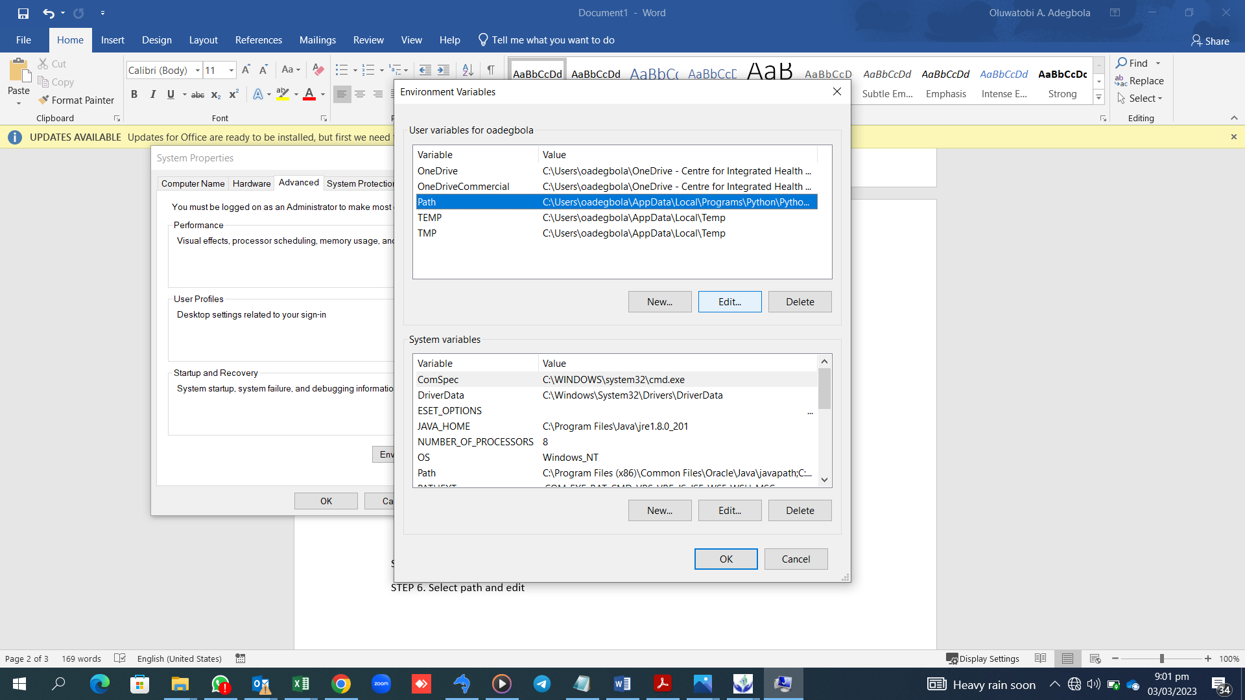

**STEP 4:** Click on new and paste the path C:\Program Files (x86)\MySQL\MySQL Server 5.7\bin

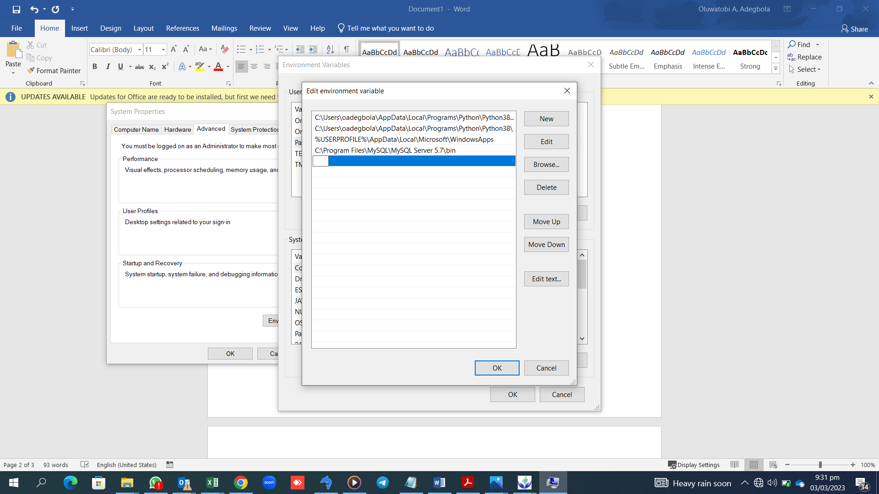

**LUNCHING THE TOOL**

Download the file and decompressed the file in any folder on your computer and look for the executable file **“GISAT_PLUS.EXE”** to lunch the tool.

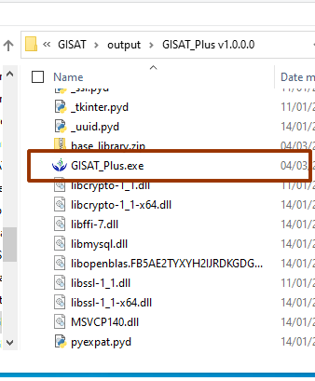

When launched you should have access to the tool as shown below

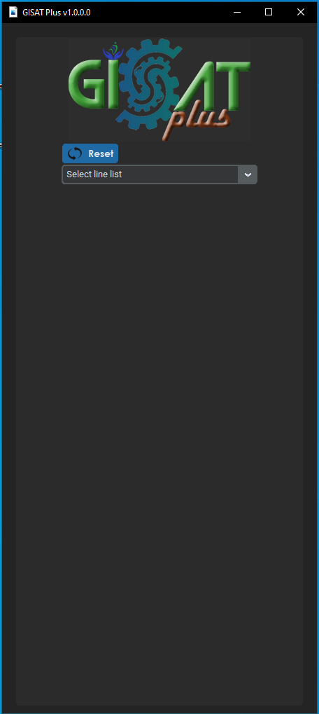

**GENERATING LINELIST**

To have access to the full functionalities of the application, click on the drop down box **‘Select line list’** to select the linelist you wish to work on/generate

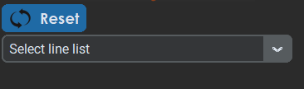

For a first time user, click on yes (Subsequent use of the app, you’re to select No).

Use the “Yes” button when using an updated or a new copy of GISAT Plus.

“No” to continue from where you stopped.

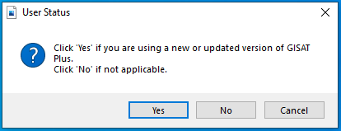

Then you will get a prompt reminding you to import the GISAT_Plus.**sql** filein the “openmrs DB. Click on OK if that is already done.

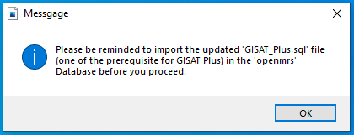

**UNDERSTANDING GISAT Plus Application**

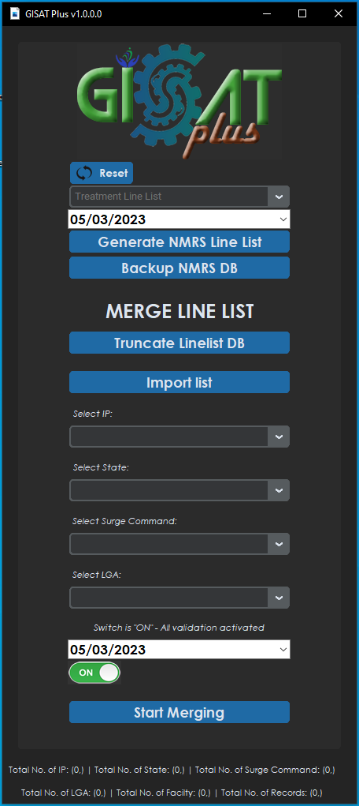

**GISAT Plus Logo**

* **Reset**
* **List of NMRS Line list (Dropdown)**
* **Multi-function**
* **Reporting date field**
* **Generate NMRS Line list**
* **Backup NMRS Database**
* **Truncate Line list DB – “validation_Linelist” merging DB**
* **Import Line list – Loading the Validation_Linelist DB**

**Merge Line List**

* **Select IP Dropdown**
* **Select State Dropdown**
* **Select Surge Command Dropdown**
* **Select LGA Dropdown**
* **Reporting Date validation “Date Field”**
* **Validation Switch**
* **Start Merging**
* **Line list Database status Panel**

**Step 9**: Select the reporting date you wish to generate the line list, then click on generate NMRS Line list

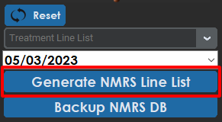 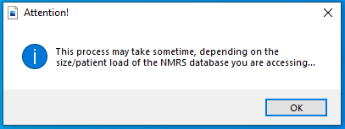

This prompt will pop up then click ok and create a folder on your PC where you will prefer the line list to be saved and save it there.

**BACKUP NMRS DB**

The tool can also be used to back up the NMRS DB by following this steps

* Select the date and click on the **“Backup NMRS DB”** select the folder you wish to save the backup on your PC and click ok

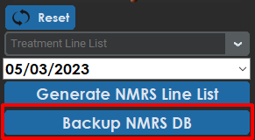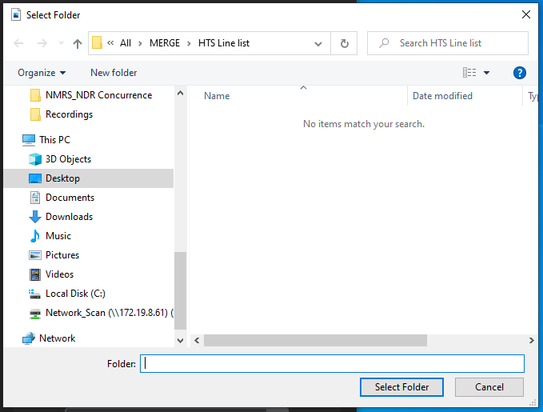

**IMPORTING LINELIST**

Import Line list by clicking on 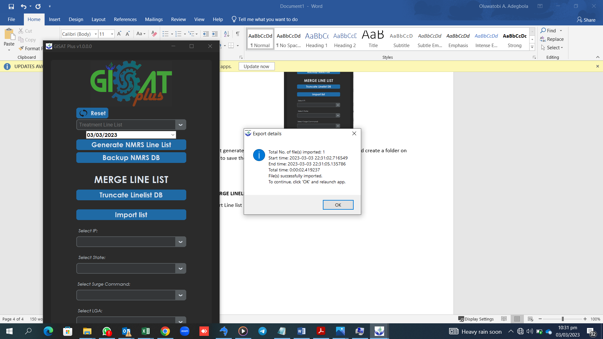

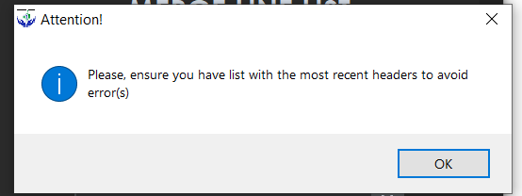

it will prompt this warning then click on OK

Then select the folder in which the linelists you wish to merge are click ok after importing a dialog box as shown below will pop up, this will alert you if your linelist have been successfully imported

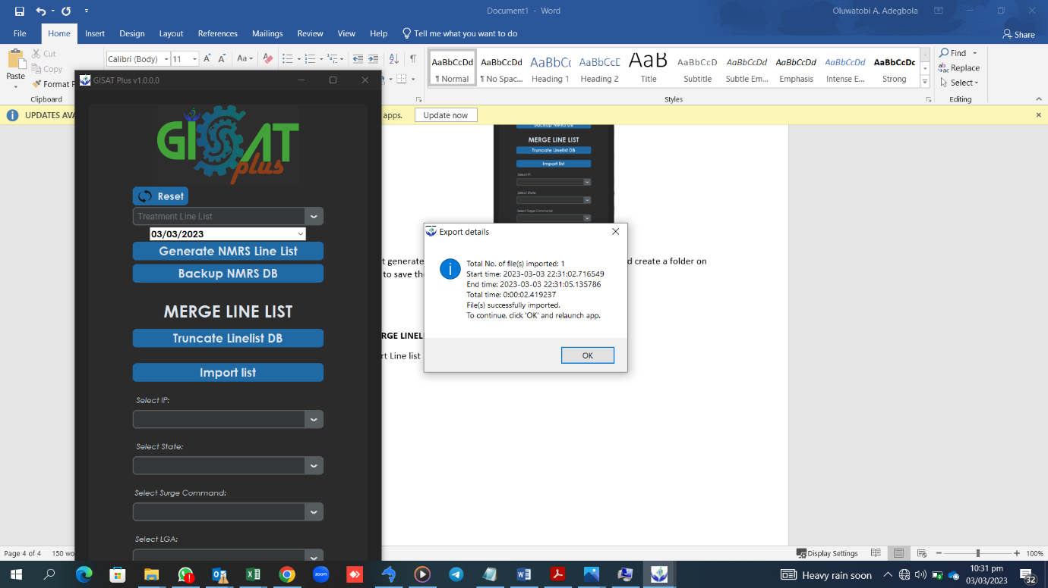

**MERGING LINELIST**

After importing linelist, Merging can now happen. To merge select the option you are merging from

Select only IP; if you are merging at the IP level

Select IP and State: if you are merging at State level

Select IP, State and Surge Command to merge at the surge command level

Select IP, state, surge command and LGA to merge at the facility or LGA level

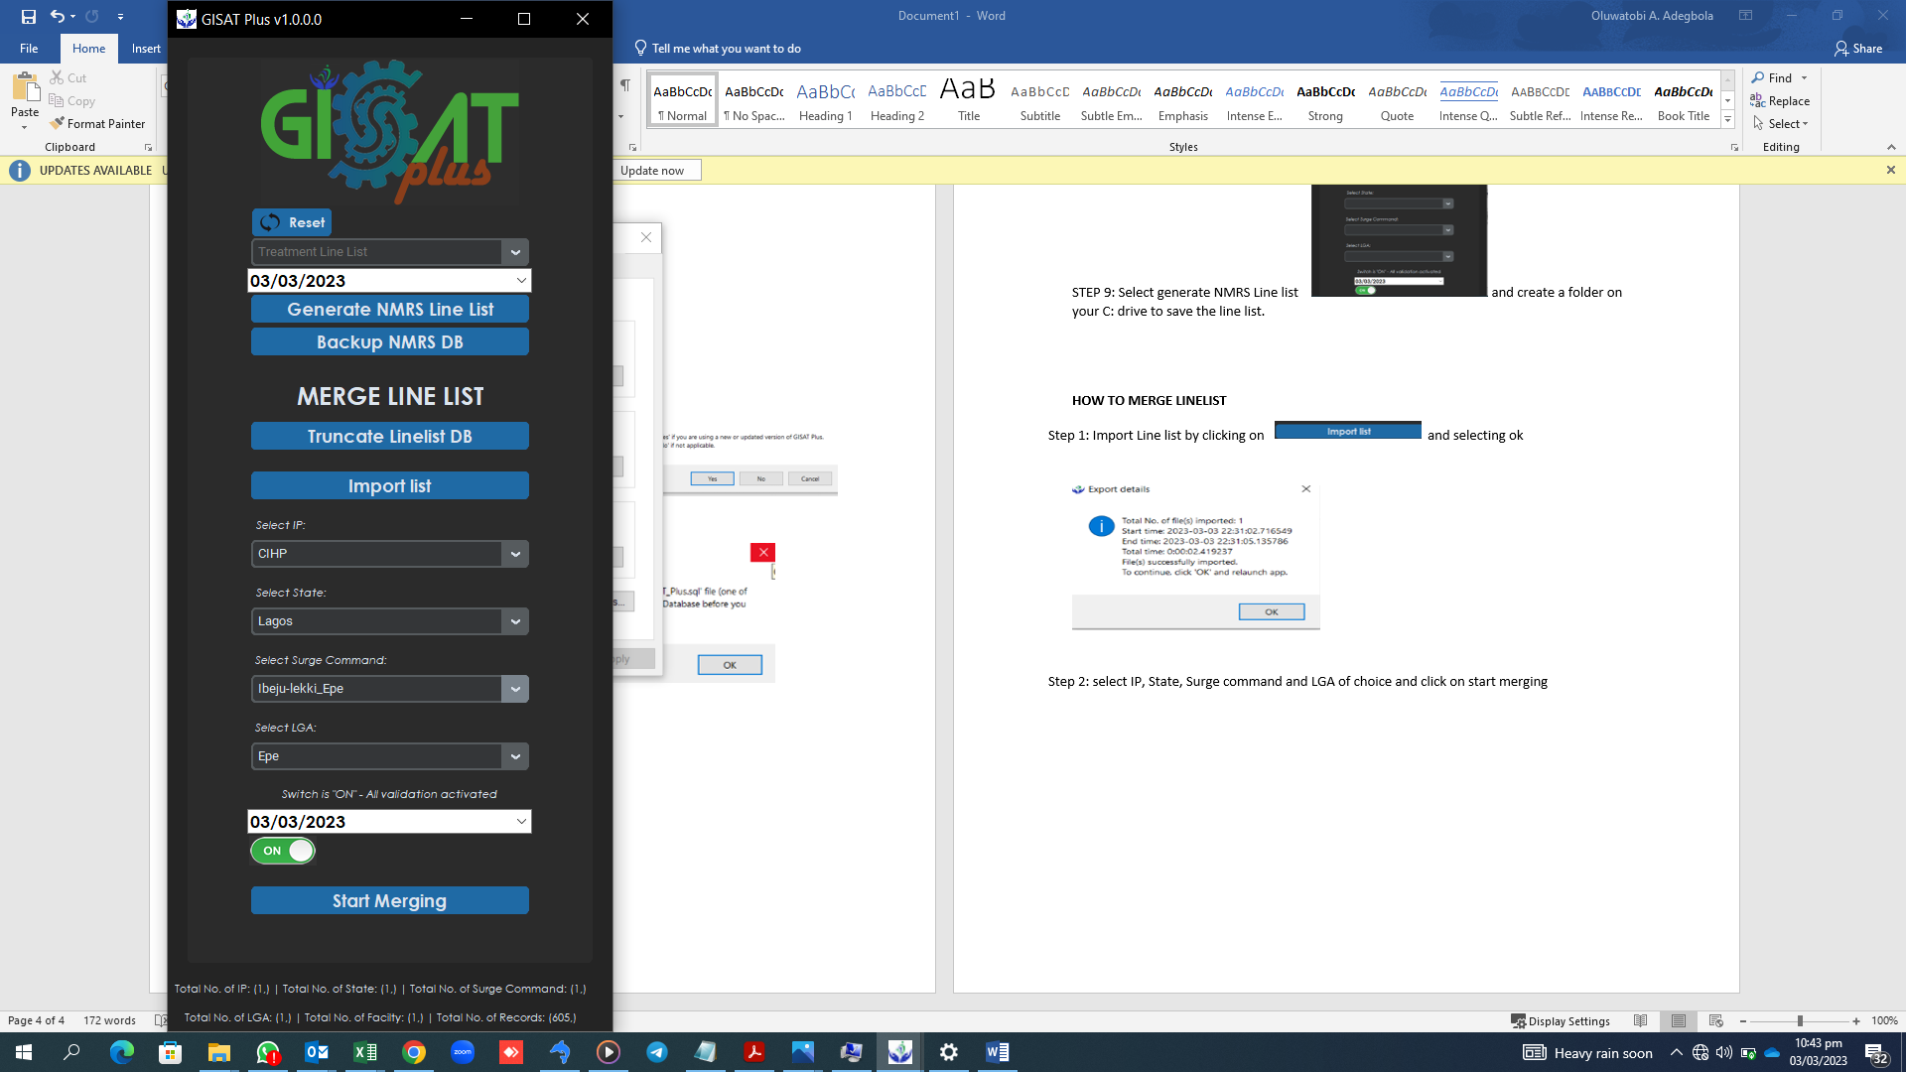

After selecting the appropriate options, select the date the linelist was generated then click on start merging.

The validation warning will pop up showing some inconsistency/validation error in the merged linelist as shown below.

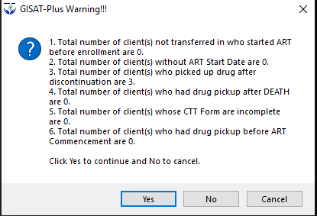

***NB: Always keep the validation on to allow for the tool to validate the imported line list before merging***